Design Document

Project 1 Phase 3

Liam Clift and Corbin Baker

Instructor: Mark Baldwin

2/2/2018

**Beyond Hope**

*Liam Clift and Corbin Baker*

**Table of Contents**

1) Cover Page

2) Title Page

3) Table of Contents

4) Design History

5) Game Overview

6) Gameplay and Mechanics

8) Story and Characters

9) Levels

10) AI

**Design History**

Nothing yet

**Game Overview**

**Concept:**

You play as a space marine. Your shipped was just attacked by aliens, and you were forced to use an escape pod to survive. Now, you must journey through the harsh planet you landed on to retake your ship.

**Genre:**

The genre is a 2D side scrolling platformer/shooter. It could be categorized as a metroid-vania style game.

**Target Audience:**

Our target audience is 18+ fans of violent games with a classic feel and new elements.

**Game Flow:**

The player will have a couple paths that branch out into dead ends with a main path to lead the to the boss for that level. The game’s general progression will be from left to right, but we would like to reward players who take the time to go down side paths by giving them slight upgrades. The game will start the player off somewhere on the left side of the level usually and to progress to the next level the player must kill the boss.

**Look and Feel:**

The look will be pixely with an arcade feel. We want to mimic the visual of arcade games like Metal Slug. We will take it a step further though down the path of Mortal Kombat. We want our game to be very violent and exciting. For example, the jungle level will have a theme of blood with the boss being a beast covered in blood in an arena of gore.

The feel will be focused on having a few tight controls that will give them the ability to adapt to new game elements easily, but also give them enough control to make them feel like they are being challenged. The best example is like how fighting games have only a few controls, but the way you can put them together will add in an element that they need to master.

**Scope:**

**Levels:** The game will have 3 locations: Jungle of Blood, Noise Caves, and The Ship.

**Enemies:** The game will have 7 enemies and 3 bosses at minimum.

**Upgrades:** The game will have 6 upgrades 2 per level.

**Gameplay and Mechanics**

**Gameplay:**

Progression:

The game will progress through levels with multiple paths many of which are dead ends with upgrades. Each of the levels will have a boss at the end that once killed will give access to the next level.

Puzzles:

The puzzles in the game will only be used as tutorials for when players get new items, such as the grenade will have an enemy that you have to arc a grenade to hit.

Objectives:

Your objective is to simply kill all the bosses in each level. The game is won when you kill the final boss, which results in you avenging your fellow marines and retaking the ship.

**Mechanics:**

Physics:

Physics will consist of basic gravity as a constant acceleration down that affects all entities and collisions. The flying enemies will be an exception to gravity for simplicity sake.

Player Movement:

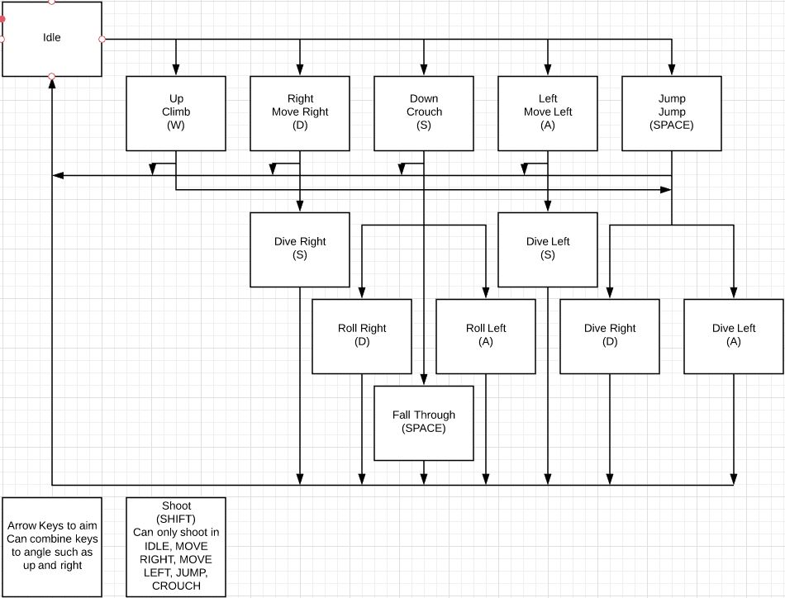

Enemy Movement:

Enemy movement will be simpler than the player’s except for bosses. There are 3 main types of enemy movement, ground, flying, and stationary. The ground will move left and right along the ground and some may be able to jump up a tile or two as well. The flying enemies will not be affected by gravity and can therefore move any direction they want to simulate flying. The stationary enemies will not move.

The first boss will move like a ground enemy. The second boss will be stationary. The third boss will have his own movement style, which will act as a mix between ground with some flying.

Objects:

There will be 3 main types of objects, background, terrain, and pick ups. Background objects will be just for decoration, so that the tile nature of levels does not visually bore the player. Terrain objects will be similar to background objects except in the foreground, so they can be any shape, they collide with the player, and some can be destroyed with enough damage. The pick up objects will be items like health packs to heal the player but also how they acquire new guns and armor.

Combat:

The player will do combat by shooting. In essence, the player will create a projectile entity that will launch from him until it hits something else, goes too far off screen, or runs out of time. The projectile(s) launched will be different depending on the selected weapon.

Melee enemies will do combat by directly colliding with the player or an attack that goes slightly further that has an accompanying animation. The ranged enemies will work similar to how the player shooting works.

Each attack will have timers before they can attack again, so that the player or an enemy doesn’t shoot 5,000 projectiles in the span of 1 second.

The player and every enemy will have health values that once fully depleted kill that entity.

**Story, Setting, and Character**

**Story:**

Backstory:

The universe is a terrible place full of threats to humanity. Marines are sent out in an attempt to preemptively strike any future foes.

Story:

Fight through the hellish planet in order to retake your ship and continue your mission.

**Characters:**

Main Character:

An initiate who must take all the training he’s had to this point to survive.

**Levels**

**Jungle of Blood:**

A lush jungle full of bloodthirsty creatures. The boss of the area is a large beast covered in blood, taking elements from the numerous species that inhabit this jungle. His arena will be lined with bodies and gore.

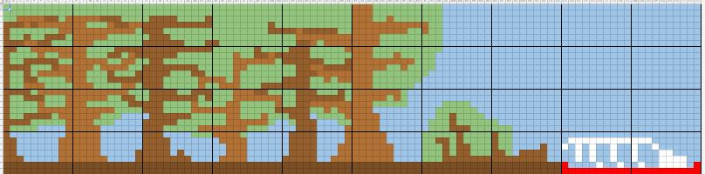

**Echo Cave:**

A cave leading into a series of catacombs, characterized by its crystalline architecture and wildlife. A stone statue of a blind woman exists in the deepest depths that “sings” to these crystals, commanding them to do her bidding.

**Destroyed Ship:**

The remnants of the ship you were stationed on. Amidst the ruin embedded in the earth, the alien species responsible for its destruction inhabits the carcass, extracting as much knowledge, resources, and even people as they can. The mother alien that controls this hivemind species sends out her commands from the chamber that once powered the ship.

**AI**

**Hearing Bubble:**

The hearing bubble will be an invisible object or radius from the enemy that when the player collides with or is inside of the enemy will be alerted to the player.

**Vision Cone:**

The vision cone works similar to the hearing bubble, except it will be a triangle in front of the enemy and will usually have a further range.

**Stop Range:**

Enemies that shoot will have a desired distance to what they want to shoot. Once they are within their stop range the enemies will shoot. If the player gets too close, they may back up. If the player gets too far, they will move up.

**Random Movement:**

Almost all the enemies will be placed then simply randomly move around in the area they spawn in.

**Art and Sound Design**

**Overview:**

The artstyle will reflect the Gamemaker engine, with pixel-based sprite work for the majority of the effort. The art should have a gritty feel, but still remain colorful and vibrant. Environments should greatly contrast from one another, giving a new feel for each level. Elements within a level will maintain a certain aesthetic or theme in order to keep designs consistent.

**Jungle:**

The jungle will have a natural, yet foreign feel about it. The jungle setting should instill a sense of familiarity, yet include elements that keep it from being “normal.” Wildlife will take elements and characteristics from real-life nature and be tweaked in order to create something unique. The boss should be the epitome of this concept, will numerous physical features from a variety of animals. As the player progresses toward the end of the level, the jungle landscape should shift to that of a horrific pool of blood, with dead animals strewn about, in order to give the boss an intimidating presence.

**Cave:**

The cave will have a more earthy and crystalline aesthetic to it. As the player progresses, this will shift to become more like a natural set of catacombs, while still retaining the crystal elements. Creatures found in this environment will have gem-like features. Stationary crystals that the player would interact with, either through puzzle or trap, should stand out from the environment in order to keep the distinction between foreground and background elements clear. The boss will be a stationary, blind, stone statue. Instead of attacking you directly, it will call on the crystals and the crystalline creatures in the room to do so for her. These crystals and creatures should have an additional effect placed onto them in order to give the statue a sense of presence.

**Ship:**

The ship will utilize the aesthetic found in science fiction films, such *Alien* and *Blade Runner.* The ship itself will be dark with neon to decorate the interior. In addition, the ship will be destroyed, so background and foreground elements will reflect this fact. The aliens inhabiting the ship will have a insect-like appearance, similar to the Zerg from *Starcraft* or the Tyranids from *Warhammer: 40,000*. The aliens will have both ranged soldier units with more humanoid features as well as berserker units that have more insect-like features. The mother alien will be a much larger version of the basic alien design, with accents on the appearance in order to make it distinct from the other aliens, while still remaining similar. The mother alien boss should not feel like the basic enemy design just scaled up.

**Music:**

The music will be utilize basic rhythms that should loop seamlessly, emphasis on the drum beat and the bass melody that reflect the tone of the level. The jungle music should feel animalistic. The cave music should feel mysterious and eerie. The ship level should feel claustrophobic and intense. Royalty-free sound effects will be added in order to accentuate these basic rhythms. However, the music will not be a focus of the game and should be used more so as a background element than anything else.